Valley of the Rocks Trek!
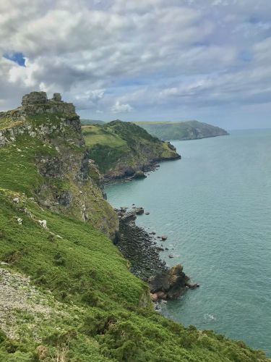
This September, please join Temwa for a spectacular 10-mile figure-of-eight loop in and around the beautiful Lynton and Lynmouth area, a dramatic and rewarding section of the North Devon coast, packed with steep climbs, sweeping sea views, natural beauty and wild coastal scenery.
This challenge may be shorter than our other treks, but it still packs a punch! A good level of fitness is essential, and participants should be prepared for plenty of ascents and descents along the way.
This is a family-friendly challenge for ages 12+, making it a brilliant opportunity for adventurous young people and adults to take on the trek together. All under-18s must be accompanied by a responsible adult.
You’ll not only challenge yourself physically but also enjoy one of the most beautiful coastal landscapes in the South West, with guidance from our excellent walk leader, who will help bring the route to life along the way.
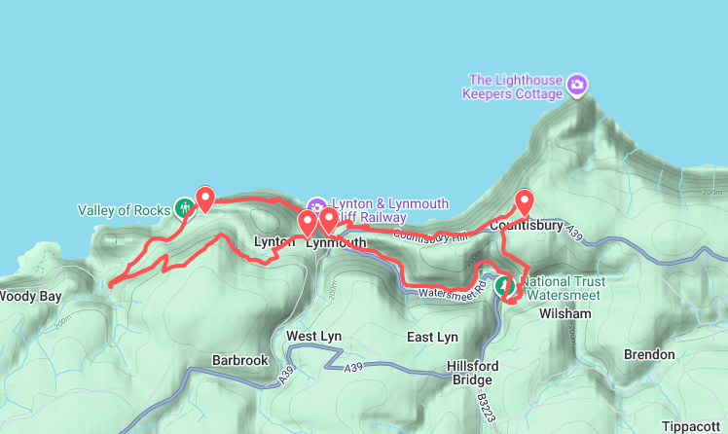
Along the way, we’ll make time for breaks, snacks and time to take in the views and, as always, there’ll be plenty of Team Temwa spirit to keep everyone going.
Drop-out points: We have included 2 potential drop-off points along the way if anyone is not feeling up to it on the day, one in Lynton and one in Lynmouth.
Start Time and Arrangements:
We will be setting off at 9am from S W Coast Path Parking at the Valley of the Rocks: S W Coast Path Lynton, and Lynmouth EX35 6JH. As the trek is taking place in September, please prepare for 4 seasons in a day!
Packing List:
A backpack- adjustable straps and a hip belt are good
Hiking footwear– you’ll need good support!
Trekking poles – optional but helpful on the steep ascents and descents
Waterproof jacket
Hiking trousers (no jeans)
Layers for all weather eventualities
Packed lunch and extra snacks
Water – at least 2 litres per person
Blister plasters and any painkillers you might need!
Changing Lives Step by Step
By gaining sponsorship for this trek, you will help to create lasting change for those living in extreme poverty in the remote rural north of Malawi and, of course, you’ll meet some wonderful new people along the way!
Climate change is a daily reality for communities in Nkhata Bay North. Intensifying droughts, floods and storms undermine food security and livelihoods and increase the cost of living for those already living in extreme poverty. Families cannot afford to send their children to school, access healthcare services or enjoy clean, safe water. With your support, these communities in Nkhata Bay North can help themselves to overcome these huge challenges.
Your fundraising target for this challenge is £250. When you share your JustGiving page with friends, colleagues and family, please remember to let them know how far their sponsorship money will go:
£10 could buy 20 books for a school library
£16 could provide safe clean water for a family
£28 could buy 4 solar lights so 4 students can study at night
£125 could plant and protect 100 trees
Sign up here to join this trek!

